Accelerator-Based Epithermal Neutron Source for BNCT
6105 Coronado Ave. NE Albuquerque, NM 87109 Website: www.linac.com
Phone: (505) 797-5614 Fax: (505) 797-5615 Email: linacinfo@linac.com
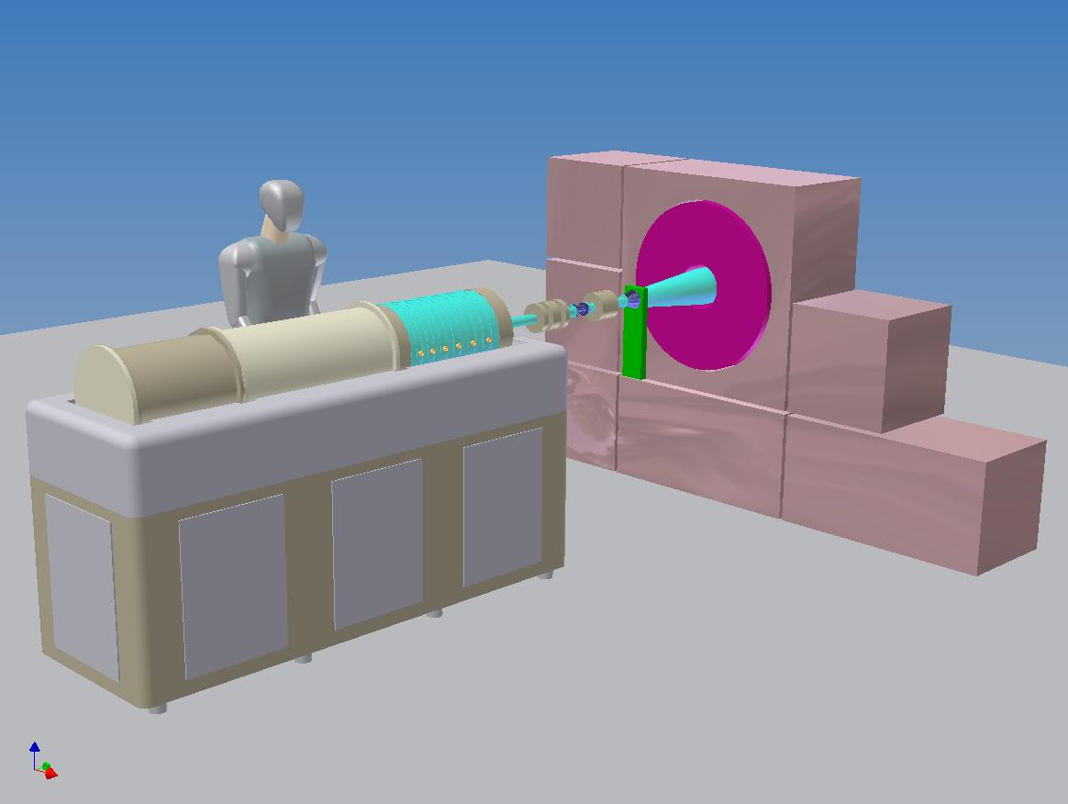
Packaging (Linac Cabinet):
Length 2.5 m
Width 0.7 m
Height (beam line) 1.2 m
Weight 1000 kg

Packaging (RF Power):
Electronic Racks 2 racks

Utilities:
Electrical Power 260 kVA
Accelerator Cooling 70 kW
Target Cooling 50 kW

Neutron Beam Options:
Solid Lithium Target
Moderator Assembly
Epithermal Neutron Flux 2.2X10⁹ n/cm²/s
Features:
ECR Microwave Ion Source
Magnetic solenoid lens LEBT
RFQ Linac to 0.75 MeV
RFI Linac to 2.5 MeV
Resonantly Coupled Linacs
Single Rf Power Drive Point
Tetrode Rf Power System

Parameters:
Beam Particle Proton
Energy 2.5 MeV
Rf Frequency 200 MHz
Beam Current (peak) 20 mA
(average) 20 mA
Beam Duty Factor (CW) 100 %
Beam Power (CW) 50 kW
Rf Cavity Power (CW) 70 kW
Rf Power (total) 120 kW
An economical Accelerator-Based Epithermal Neutron Source (ABENS) for the BNCT application! Based on the latest development in linac technology, the revolutionary RFI Linac Structure, this unit offers higher efficiency operation from smaller units at lower cost. While still under development, these projections are based on well-established accelerator development techniques. To get the latest information on this and other related devices, please visit our website: www.linac.com.

